**Ergonomic Standing Desks**

***(Ergonomic purchases greater than $100 require a***

***Doctor’s supporting documentation)***

**You may only choose and purchase from the options below\***

[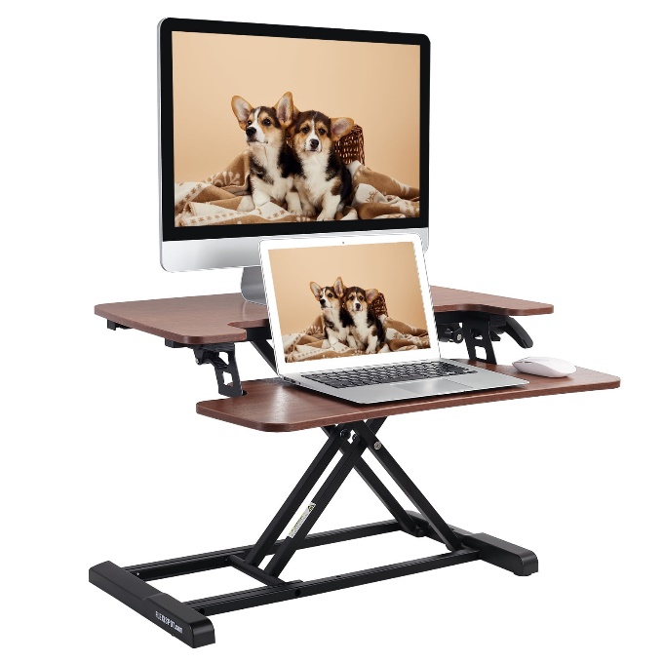](https://www.walmart.com/ip/FLEXISPOT-Home-Office-Height-Adjustable-Standing-Desk-Converter-Mahogany-28-U-Shape-with-Keyboard-Tray/847922363?wmlspartner=wlpa&selectedSellerId=101100988&sourceid=dsn_ad_82a1172e-9aef-4deb-a6c1-b1278a1d5253&veh=dsn&wmlspartner=dsn_ad_82a1172e-9aef-4deb-a6c1-b1278a1d5253&cn=FY25-MP-PMAX2_cnv_dps_dsn_dis_ad_mp_s_n&gclsrc=aw.ds&wl9=pla&wl11=online&gad_source=1&gclid=CjwKCAiAn9a9BhBtEiwAbKg6fuHjSYuHLrA7XpBc41kcjnshRccuvy5yEIFPlD5yt74quA-asUSQRhoCPqgQAvD_BwE) [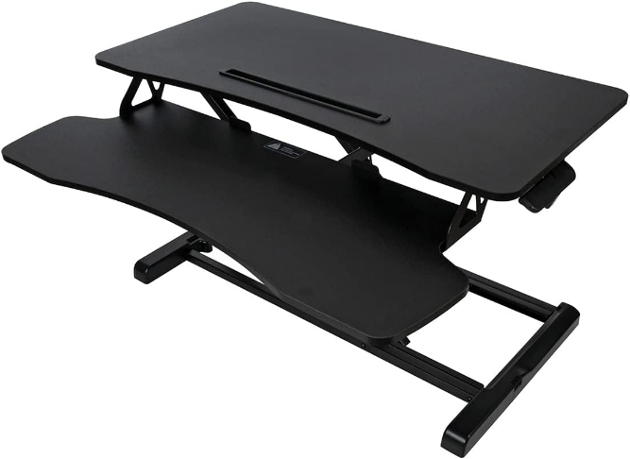](https://www.amazon.com/Royal-Adjustable-Standing-Keyboard-Support/dp/B09HR9R8M8/ref=asc_df_B09HR9R8M8?mcid=f58ab454d2df33e899885aadabad7442&hvocijid=11072006123090586553-B09HR9R8M8-&hvexpln=73&tag=hyprod-20&linkCode=df0&hvadid=730432682330&hvpos=&hvnetw=g&hvrand=11072006123090586553&hvpone=&hvptwo=&hvqmt=&hvdev=c&hvdvcmdl=&hvlocint=&hvlocphy=1018611&hvtargid=pla-2281435177178&psc=1)

Option 1: [**(Click for Link)**](https://www.walmart.com/ip/FLEXISPOT-Home-Office-Height-Adjustable-Standing-Desk-Converter-Mahogany-28-U-Shape-with-Keyboard-Tray/847922363?wmlspartner=wlpa&selectedSellerId=101100988&sourceid=dsn_ad_82a1172e-9aef-4deb-a6c1-b1278a1d5253&veh=dsn&wmlspartner=dsn_ad_82a1172e-9aef-4deb-a6c1-b1278a1d5253&cn=FY25-MP-PMAX2_cnv_dps_dsn_dis_ad_mp_s_n&gclsrc=aw.ds&wl9=pla&wl11=online&gad_source=1&gclid=CjwKCAiAn9a9BhBtEiwAbKg6fuHjSYuHLrA7XpBc41kcjnshRccuvy5yEIFPlD5yt74quA-asUSQRhoCPqgQAvD_BwE) Option 2: [**(Click for Link)**](https://www.amazon.com/Royal-Adjustable-Standing-Keyboard-Support/dp/B09HR9R8M8/ref=asc_df_B09HR9R8M8?mcid=f58ab454d2df33e899885aadabad7442&hvocijid=11072006123090586553-B09HR9R8M8-&hvexpln=73&tag=hyprod-20&linkCode=df0&hvadid=730432682330&hvpos=&hvnetw=g&hvrand=11072006123090586553&hvpone=&hvptwo=&hvqmt=&hvdev=c&hvdvcmdl=&hvlocint=&hvlocphy=1018611&hvtargid=pla-2281435177178&psc=1)

[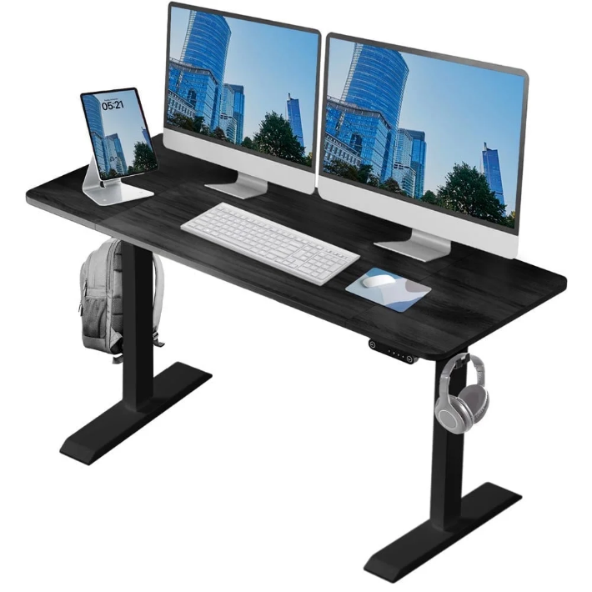](https://www.walmart.com/ip/Electric-Height-Adjustable-Workstation-Desk-Sit-Stand-Work-Styles-60x24in-Black/14622112250?wmlspartner=wlpa&selectedSellerId=5635&sourceid=dsn_ad_82a1172e-9aef-4deb-a6c1-b1278a1d5253&veh=dsn&wmlspartner=dsn_ad_82a1172e-9aef-4deb-a6c1-b1278a1d5253&cn=FY25-MP-PMAX2_cnv_dps_dsn_dis_ad_mp_s_n&gclsrc=aw.ds&wl9=pla&wl11=online&gad_source=1&gclid=CjwKCAiAn9a9BhBtEiwAbKg6fhBbPExigqkBhjkyLmEd_hUMX5yx9jspNzbRta-6ZDScyim77eAXjRoCIecQAvD_BwE) [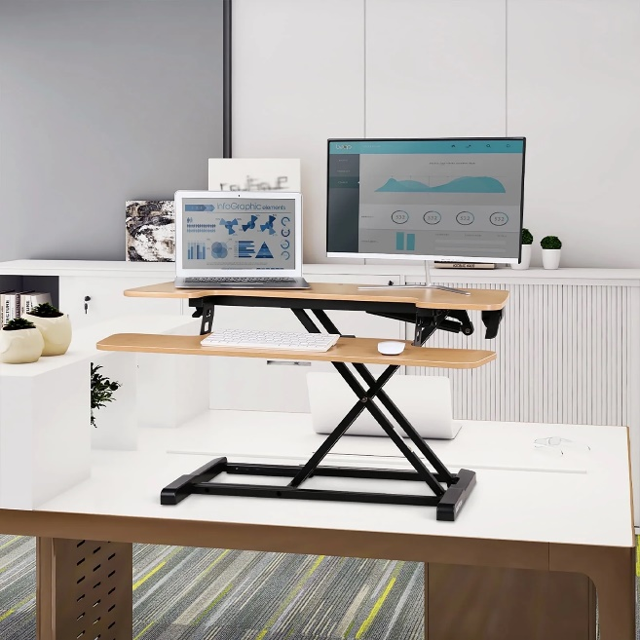](https://www.walmart.com/ip/FLEXISPOT-Home-Office-Height-Adjustable-Standing-Desk-Converter-Bamboo-Texture-35-U-Shape-with-Keyboard-Tray/852329262)

Option 3: [**(Click for Link)**](https://www.walmart.com/ip/Electric-Height-Adjustable-Workstation-Desk-Sit-Stand-Work-Styles-60x24in-Black/14622112250?wmlspartner=wlpa&selectedSellerId=5635&sourceid=dsn_ad_82a1172e-9aef-4deb-a6c1-b1278a1d5253&veh=dsn&wmlspartner=dsn_ad_82a1172e-9aef-4deb-a6c1-b1278a1d5253&cn=FY25-MP-PMAX2_cnv_dps_dsn_dis_ad_mp_s_n&gclsrc=aw.ds&wl9=pla&wl11=online&gad_source=1&gclid=CjwKCAiAn9a9BhBtEiwAbKg6fhBbPExigqkBhjkyLmEd_hUMX5yx9jspNzbRta-6ZDScyim77eAXjRoCIecQAvD_BwE) Option 4: [**(Click for Link)**](https://www.walmart.com/ip/FLEXISPOT-Home-Office-Height-Adjustable-Standing-Desk-Converter-Bamboo-Texture-35-U-Shape-with-Keyboard-Tray/852329262) **Ergonomic Keyboards and Mouse**

[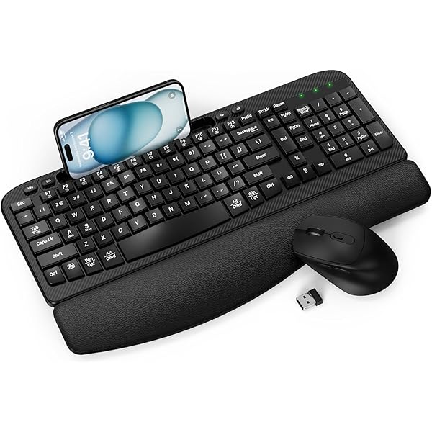](https://www.amazon.com/Wireless-Keyboard-EAYBLLY-Ergonomic-Cushioned/dp/B0D94V544S/ref=sr_1_15?crid=17U2O6N6AEAAI&dib=eyJ2IjoiMSJ9.PzAqHSNTD9OWm7hJobyIKksddBjM2oGg5x9_b7m0S86bn0JmIC9KOVzrp5vnN814kIvbW4lNhrGdbqjrfkOxxBzNuwWkeIYvBphNN0Nnl6Eq2598Od7gJDiGIvT-F40NUMxP-0I1-ZtOSkC_FNLtcvbfDNc_zkc3VmU6fZmlKA-17pTNLnWa29NWA9NGeObWFQRASxKdJsOjjGReoQW_CvJ7hezjvvbMK9CUAdHMSTg.-xdLa0MqfwNLDCETe9YD3wiCmXZ7aor3gg1nuSJlaZU&dib_tag=se&keywords=ergonomic%2Bkeyboard%2Band%2Bmouse&qid=1739456703&sprefix=ergonomic%2Bkeyboard%2Band%2Bmouse%2Caps%2C139&sr=8-15&th=1) 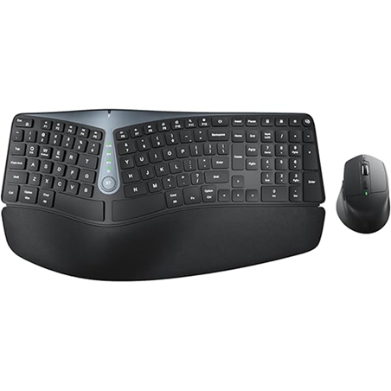

Option 1: [**(Click for Link)**](https://www.amazon.com/Wireless-Keyboard-EAYBLLY-Ergonomic-Cushioned/dp/B0D94V544S/ref=sr_1_15?crid=17U2O6N6AEAAI&dib=eyJ2IjoiMSJ9.PzAqHSNTD9OWm7hJobyIKksddBjM2oGg5x9_b7m0S86bn0JmIC9KOVzrp5vnN814kIvbW4lNhrGdbqjrfkOxxBzNuwWkeIYvBphNN0Nnl6Eq2598Od7gJDiGIvT-F40NUMxP-0I1-ZtOSkC_FNLtcvbfDNc_zkc3VmU6fZmlKA-17pTNLnWa29NWA9NGeObWFQRASxKdJsOjjGReoQW_CvJ7hezjvvbMK9CUAdHMSTg.-xdLa0MqfwNLDCETe9YD3wiCmXZ7aor3gg1nuSJlaZU&dib_tag=se&keywords=ergonomic%2Bkeyboard%2Band%2Bmouse&qid=1739456703&sprefix=ergonomic%2Bkeyboard%2Band%2Bmouse%2Caps%2C139&sr=8-15&th=1) Option 2: [**(Click for Link)**](https://www.amazon.com/Ergonomic-Bluetooth-Cushioned-Multi-Device-Rechargeable/dp/B0D7357VP5/ref=sxin_16_pa_sp_search_thematic_sspa?content-id=amzn1.sym.f365033e-b793-4e66-b7ff-67f86c886ec7%3Aamzn1.sym.f365033e-b793-4e66-b7ff-67f86c886ec7&cv_ct_cx=ergonomic%2Bkeyboard%2Band%2Bmouse&keywords=ergonomic%2Bkeyboard%2Band%2Bmouse&pd_rd_i=B0D7357VP5&pd_rd_r=1a454c5d-b0bf-472d-950e-3985f2759008&pd_rd_w=t2orA&pd_rd_wg=oQMBa&pf_rd_p=f365033e-b793-4e66-b7ff-67f86c886ec7&pf_rd_r=SNFRVFPEZNYZX35QKD97&qid=1739458889&sbo=RZvfv%2F%2FHxDF%2BO5021pAnSA%3D%3D&sr=1-1-7efdef4d-9875-47e1-927f-8c2c1c47ed49-spons&sp_csd=d2lkZ2V0TmFtZT1zcF9zZWFyY2hfdGhlbWF0aWM&psc=1)

[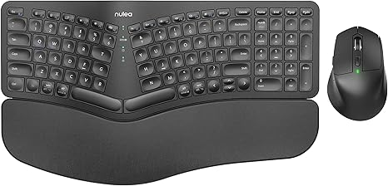](https://www.amazon.com/Nulea-KM75-Comfortable-Multi-Device-Rechargeable/dp/B0D1C7P326/ref=sr_1_10?dib=eyJ2IjoiMSJ9.PzAqHSNTD9OWm7hJobyIKmBwDnF6z6LsI_Et09HlzPaOfQlNf3D8IRKjg1BMYM19iwKGnn7UaP2Tlc1d_xjvBsnJ1hJWDWdO9Fh0Zugou99Q0eI5IeGiTGX3P7wxptIbtEM2zmmUMh7Bw_4LW5kFTL5dEVJZSS_SXQ8otCzVcZLqqVl0mI7GP45PVV7M2mB0vLQ13ZwOZkjFIHbX4mIPCH9FfkichraY80ojp5g2owY.ZSP__kkpVcfGtLkDE6MiHopMnGn-VoO-3bSpID-vhrc&dib_tag=se&keywords=ergonomic%2Bkeyboard%2Band%2Bmouse&qid=1739458889&sr=8-10&th=1)

Option 3: [**(Click for Link)**](https://www.amazon.com/Nulea-KM75-Comfortable-Multi-Device-Rechargeable/dp/B0D1C7P326/ref=sr_1_10?dib=eyJ2IjoiMSJ9.PzAqHSNTD9OWm7hJobyIKmBwDnF6z6LsI_Et09HlzPaOfQlNf3D8IRKjg1BMYM19iwKGnn7UaP2Tlc1d_xjvBsnJ1hJWDWdO9Fh0Zugou99Q0eI5IeGiTGX3P7wxptIbtEM2zmmUMh7Bw_4LW5kFTL5dEVJZSS_SXQ8otCzVcZLqqVl0mI7GP45PVV7M2mB0vLQ13ZwOZkjFIHbX4mIPCH9FfkichraY80ojp5g2owY.ZSP__kkpVcfGtLkDE6MiHopMnGn-VoO-3bSpID-vhrc&dib_tag=se&keywords=ergonomic%2Bkeyboard%2Band%2Bmouse&qid=1739458889&sr=8-10&th=1)

**Ergonomic Chairs**

**[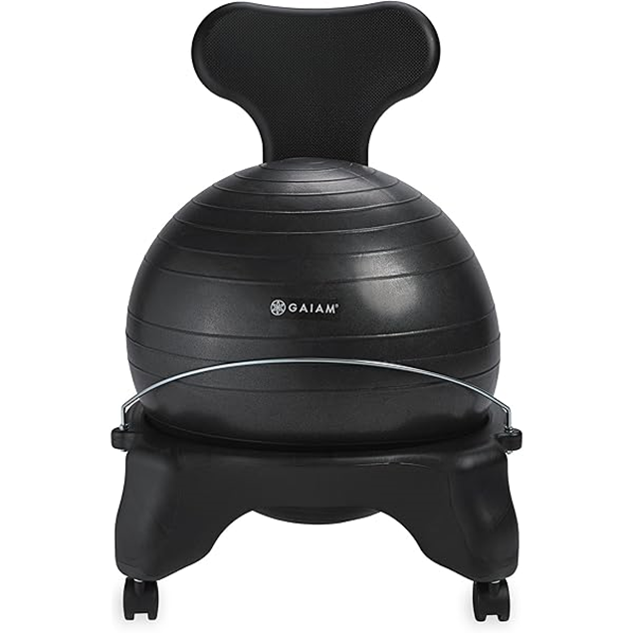](https://www.amazon.com/dp/B0007VB4NE/ref=twister_B006JBWYDA?_encoding=UTF8&th=1)**[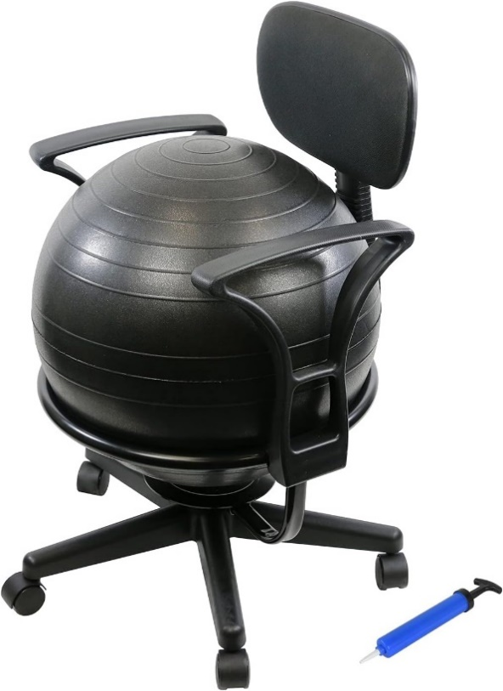](https://www.amazon.com/CanDo-Metal-Ball-Chair-Arms/dp/B001VAKAWQ/ref=sr_1_13_sspa?crid=3UV105EINJ3WV&dib=eyJ2IjoiMSJ9.DewYwjkL_soI-ETa9x_XHNAEgsEwW-DbhP5hV6ZIXbnFcMYspDffiAYX9hXEcY8W0HpgebVQU2yzhFC6bCtQJPr53UpFuqR0F2vvQVhP-StEGEQivJurE3P6m5N3qbGNy6oJnm6B33G8HU8HaxqzkMRrVWL3RQbuxDJzBEIvgJr-KV7R5qW312oaaSbm-9IxasQK0scJOdKd86iTd4_03dXfU1oTLbGCeHv47enWMhXFGFBlUlW8UciHBwu5aVVhGVML5c9DWirQ93sUQCImCk2BBD7M0PjrY5mJPX-eQ-4.NUZokEZlPJVqcCsmkr5Qhn5jCUmg5jmRa6OZMjKPuho&dib_tag=se&keywords=balance%2Bball%2Bchairs%2Bergonomic&qid=1739460210&sprefix=balance%2Bball%2Bchairs%2Bergonomic%2Caps%2C96&sr=8-13-spons&sp_csd=d2lkZ2V0TmFtZT1zcF9tdGY&th=1)

Option 1: [**(Click for Link)**](https://www.amazon.com/dp/B0007VB4NE/ref=twister_B006JBWYDA?_encoding=UTF8&th=1) Option 2: [**(Click for Link)**](https://www.amazon.com/CanDo-Metal-Ball-Chair-Arms/dp/B001VAKAWQ/ref=sr_1_13_sspa?crid=3UV105EINJ3WV&dib=eyJ2IjoiMSJ9.DewYwjkL_soI-ETa9x_XHNAEgsEwW-DbhP5hV6ZIXbnFcMYspDffiAYX9hXEcY8W0HpgebVQU2yzhFC6bCtQJPr53UpFuqR0F2vvQVhP-StEGEQivJurE3P6m5N3qbGNy6oJnm6B33G8HU8HaxqzkMRrVWL3RQbuxDJzBEIvgJr-KV7R5qW312oaaSbm-9IxasQK0scJOdKd86iTd4_03dXfU1oTLbGCeHv47enWMhXFGFBlUlW8UciHBwu5aVVhGVML5c9DWirQ93sUQCImCk2BBD7M0PjrY5mJPX-eQ-4.NUZokEZlPJVqcCsmkr5Qhn5jCUmg5jmRa6OZMjKPuho&dib_tag=se&keywords=balance%2Bball%2Bchairs%2Bergonomic&qid=1739460210&sprefix=balance%2Bball%2Bchairs%2Bergonomic%2Caps%2C96&sr=8-13-spons&sp_csd=d2lkZ2V0TmFtZT1zcF9tdGY&th=1) [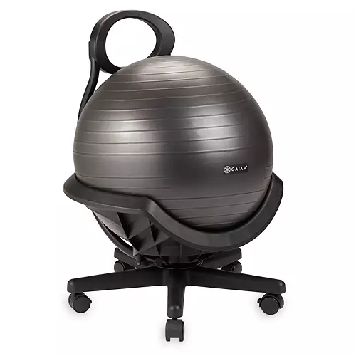](https://www.dickssportinggoods.com/p/gaiam-ultimate-balance-ball-chair-with-swivel-22gimaltmtblncblleac/22gimaltmtblncblleac?sku=23982266&camp=CSE:DSG__pla___71700000119529849&segment=&gad_source=4&gclid=Cj0KCQiAwtu9BhC8ARIsAI9JHanaKhTD5AuEC01rKOQPBWM6P46RYIeGnNp4hrPP2FMTEfgH2w0ss_4aAnEWEALw_wcB&gclsrc=aw.ds)

Option 3: [**(Click for Link)**](https://www.dickssportinggoods.com/p/gaiam-ultimate-balance-ball-chair-with-swivel-22gimaltmtblncblleac/22gimaltmtblncblleac?sku=23982266&camp=CSE:DSG__pla___71700000119529849&segment=&gad_source=4&gclid=Cj0KCQiAwtu9BhC8ARIsAI9JHanaKhTD5AuEC01rKOQPBWM6P46RYIeGnNp4hrPP2FMTEfgH2w0ss_4aAnEWEALw_wcB&gclsrc=aw.ds)