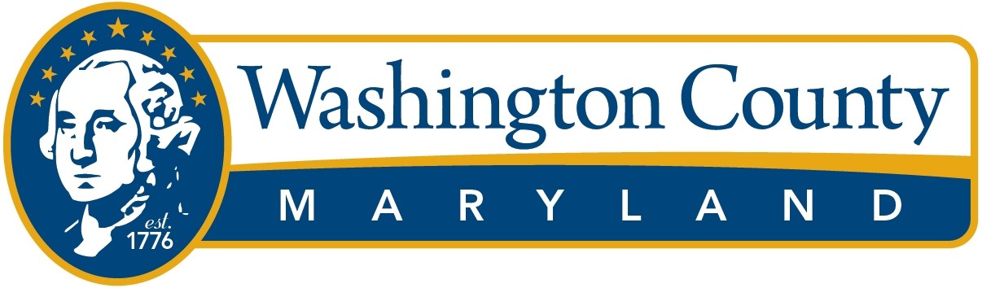

**Employee Investment Program**

The Board of County Commissioners is committed to the health, safety, and welfare of its employees. Not only are employees encouraged to take steps to increase their knowledge, skills and overall effectiveness in the workplace, but they are also encouraged to take steps to improve their overall health and well-being outside the workplace. The County is committed to making appropriate resources and funding available to employees to work towards fulfilling their personal, professional, and wellness goals. The Employee Investment Program will consist of two initiatives which include Employee Development and Team Building.

The Human Resources Department will be responsible for tracking and managing the Employee Investment Program. The Human Resources department will work directly with employees and managers to utilize these funds in the most constructive and cost-effective manner.

**Employee Development**

The County supports investing in its employees and will provide resources available for personal wellness, personal health and safety, and personal development. Every regular, full-time employee will be able to utilize up to $200 for this Employee Development category. The event, activity, or purchase must be limited to only the employee’s use.

Personal Wellness

This includes activities, events, exercise classes, fitness memberships and fitness items that promote the employee’s personal wellness goals and benefit the employee’s overall health and well-being.

Personal Health & Safety

This includes safety items that are beneficial or required for the employee in the course of employment. This would include items like prescription safety glasses, alternative hearing protection, work boots/shoes for eligible field personnel, etc. The program will reimburse up to $125 for a pair of work boots/shoes for eligible field personnel. You can use any remaining funds on other eligible purchases. If the employee has already been reimbursed for work boots/shoes through another program, this program cannot be used to purchase an additional pair (we can only reimburse for one pair of work boots per fiscal year).

Items such as personal safety alarms are included in this category as well. Personal safety alarms increase the employees’ safety as they walk to and from the workplace.

This category also includes items that are not currently provided that can make your workspace more comfortable, resulting in greater productivity. This includes ergonomic office items such as standing desks, ergonomic mice, ergonomic keyboards, ergonomic office chairs, etc. Employees must choose from ergonomic office items provided in the Ergonomic Office Equipment Catalog in order to be reimbursed through this program. Ergonomic office items over $100 will require a doctor’s note indicating medical necessity to gain approval. Ergonomic office items reimbursed through the Employee Investment Program are to be used by the employee during the course of employment. Therefore, these items are expected to remain at the workplace. However, the employee may keep these items at the time they leave employment.

This program does not allow duplicate purchases of the same item or type of item. This is at the discretion of the Department of Human Resources.

Personal Development

This includes educational seminars, workshops, and courses that result in an employee developing knowledge or skills that help the employee professionally.

Employees may make up to two requests in a fiscal year. The maximum reimbursement will remain $200 per employee. There will be no balance carryover from year to year.

Employee Waiver, Release, and/or Discharge of Liability

By participating in the Employee Investment Program, the employee hereby releases, waives, and/or discharges the County from any and all liability arising from or relating to any personal injury, damage to property, or any other claim or cause of action related to the employee’s participating in the Employee Investment Program.

The employee participating in the Employee Investment Program hereby holds the County harmless from any liabilities or claims made as a result of participation in the Employee Investment Program.

Employee Development Application Process

1. If the request is not covered on the Items Already Approved List, the employee shall request pre-approval from the Human Resources Department prior to the purchase or registration of the seminar, workshop, course, or other personal wellness initiative. The employee can use the Employee Development Form for the pre-approval request. If the item or activity is on the Already Approved List, the employee may skip to step 3.
2. The Human Resources Department will approve or deny the request. In some circumstances, the Human Resources Department may seek approval from the employee’s department head or supervisor if relevant to the request. Notification of the approval or denial will be made to the employee.
3. Once approved, the employee continues with the requested event, activity, or purchase.
4. Once completed, the employee will submit the Employee Development Form along with a copy of the original receipt(s) to the Human Resources Department for final approval. If a County P-Card was used for the purchase, the Business Expense Form procedure must be followed.
5. The Human Resources Department will review the form, and all provided receipts to provide the final approval. After the final approval, the documents are submitted for reimbursement. Reimbursement to individuals for this Employee Investment initiative will be made on the employee’s paycheck in accordance with IRS regulations and County policy. If the employee elects to use the designated $200 for job-related training, educational seminars, workshops, or courses, this will not be reimbursed via the employee’s paycheck but through the Accounts Payable Department.

**Team Building**

The County recognizes and supports team building activities which improve workplace culture and productivity. Team building activities can improve communication and collaboration among team members, foster a sense of unity, enhance productivity, and strengthen relationships within a team. Departments can utilize the Human Resources Department for ideas and planning of Team Building events. Team building can be broken down into two categories, Team Development and Team Identity. The Department will be budgeted $50 per full-time employee annually for team building.

Team Development

This includes team activities such as educational workshops and seminars that are inclusive of the entire team.

Activities such as mini-golf, picnic lunches, and other activities that are focused on improving team dynamics, relationships, communication, etc. would also be included.

Team Identity

This would include items such as team polos and other apparel items that can be worn in the course of employment. These items should identify you as a member of a team. The products must be consistent with the County’s organizational branding and feature a current approved logo.

Criteria for Team Building

* Events and/or products must be inclusive of the entire team. Part-time employees can be included in teambuilding events, but the budget will remain the same at $50 per full-time employee.
* A team building event may occur during work hours if it does not interrupt the daily operations of the department. If a team building event will take staff off-site during work hours, this should be discussed with the Human Resources Department to gain approval prior to proceeding.
* Team building products must be consistent with the County’s organizational branding. Products must use the current approved logo. Departments are not permitted to develop and design a new logo to be placed on these items without appropriate approval.
* Any team building event where there is a moderate level of risk involved will need prior approval from the Human Resources Department prior to proceeding.

The Human Resources Department will reach out to departments to help promote and plan team-building activities as needed.

Team Building Application Process

1. If the request is not covered on the Items Already Approved List, the supervisor shall request pre-approval from the Human Resources Department prior to the activity or purchase. The supervisor can use the Team Building Form for the pre-approval request. If the item or activity is on the Already Approved list, the employee may skip to step 3.
2. The Human Resources Department will approve or deny the request. Notification of the approval or denial will be made to the individual submitting the request.
3. Once approved, the supervisor continues with the requested teambuilding event, activity, or purchase.
4. After completion of the event, the Team Building Form along with a copy of the original receipt(s) should be submitted to Human Resources for final approval. The Human Resources Department will review the form, and all provided receipts to provide the final approval. After the final approval, the documents are submitted for reimbursement. If items are purchased using a p-card, the Business Expense Form procedure must be followed.

Employee Investment Program Exclusions:

* The program will not pay or reimburse for any activity including alcohol
* The program will not pay or reimburse for any event that would exhibit a negative image for the County
* The program will not pay or reimburse for any activities that could present a safety risk to our employees. Any activity with even a moderate level of risk involved should receive prior approval from the Human Resources Department.
* The program will not pay or reimburse for the purchase or use of any weapons including but not limited to handguns, ammunition, knives, throwing axes, stun guns, pepper spray, etc.
* The program will not reimburse co-pays or deductibles incurred while using your benefit plans
* The program will not pay or reimburse anything that goes against County’s business expense travel/reimbursement policies and procedures (this includes the purchase of paper or plastic products- napkins, cups, utensils, etc.).

The employee must provide a copy of the original receipt for reimbursement. The program will not reimburse purchases based on credit card statements or bank statements. In addition, it is essential that the County’s business expense reimbursement policies and procedures are followed for all parts of this program. Anyone who does not follow these policies and procedures will not be reimbursed for such expenses. If these purchases are paid via a county p-card, you will be responsible for reimbursing the County for any ineligible expenses.

The Human Resources Department will keep a list of already approved items, activities and events. If the item, activity or event is on the list, there is no pre-approval needed. Specific options will be provided as part of the list that employees can choose from.